**Part 1. Network Layer Analysis:**

**Part 1.1 ICMP Analysis:**

**Q1-** As can be seen from the below screenshots when I run **“traceroute -I www.uq.edu.au”** 29 hops performed to reach the destination. The minimum TTL less than which the traceroute messages do not reach to a destination is 29. When I run **“traceroute -I -m 19 www.study.uq.edu.au” which limits max TTL to 19** it does not reach the IP address it reached before(in ss.1) as can be seen in ss2.

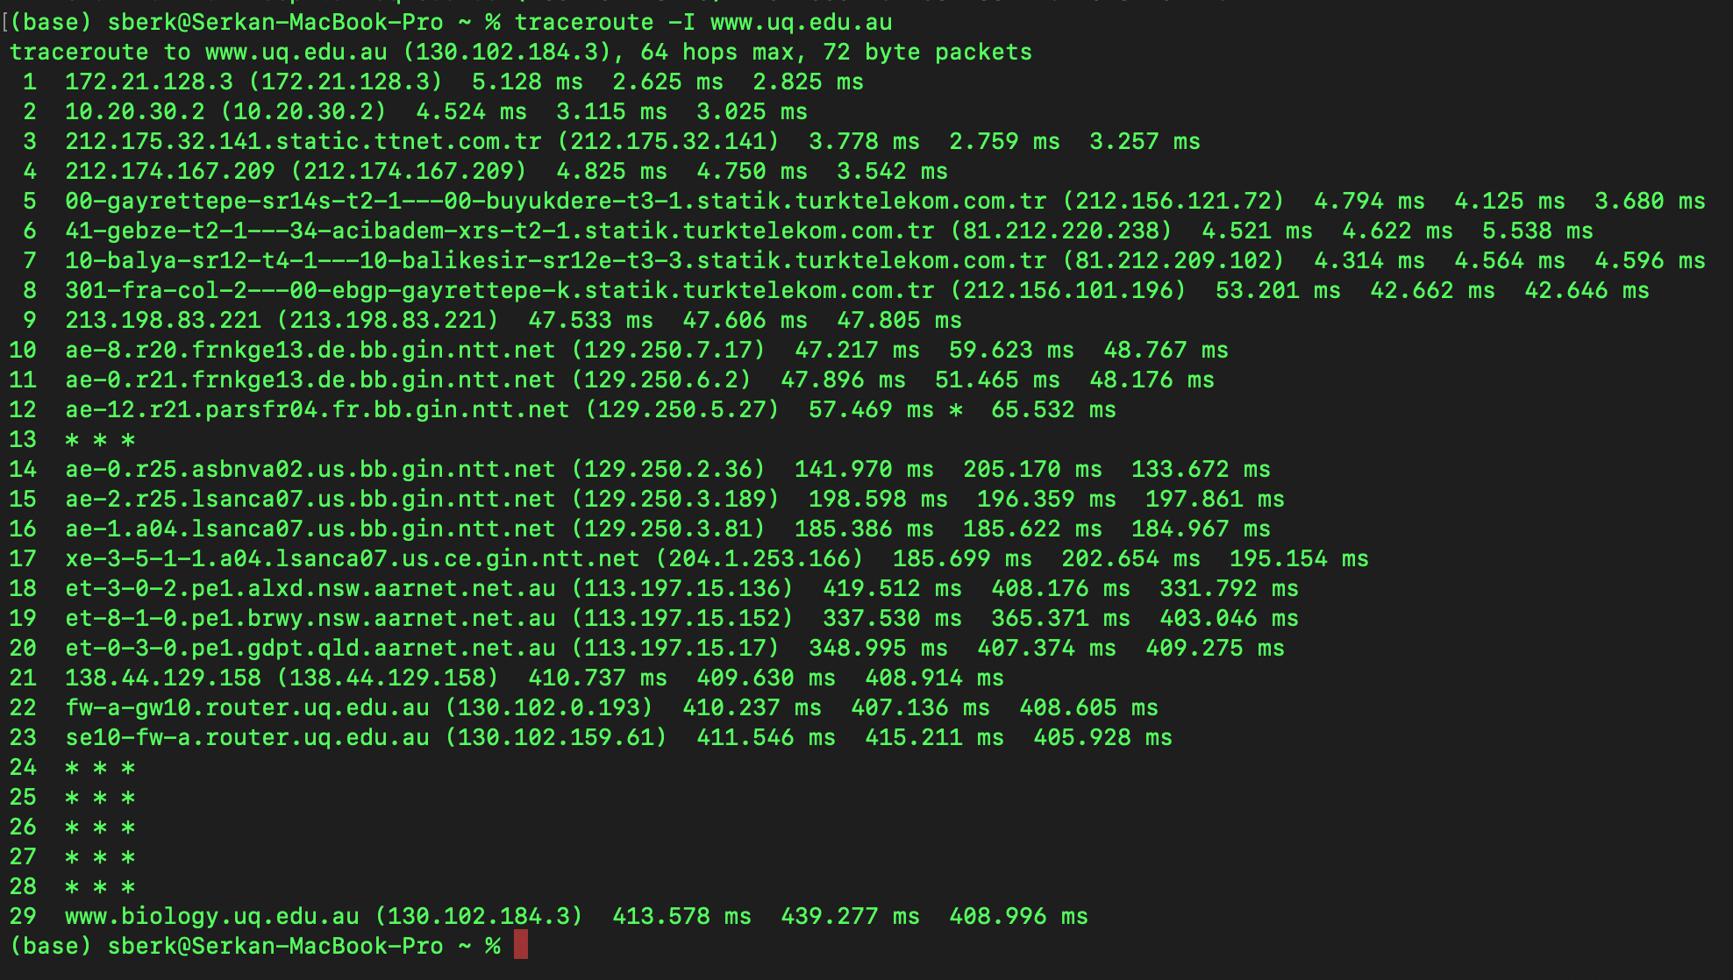

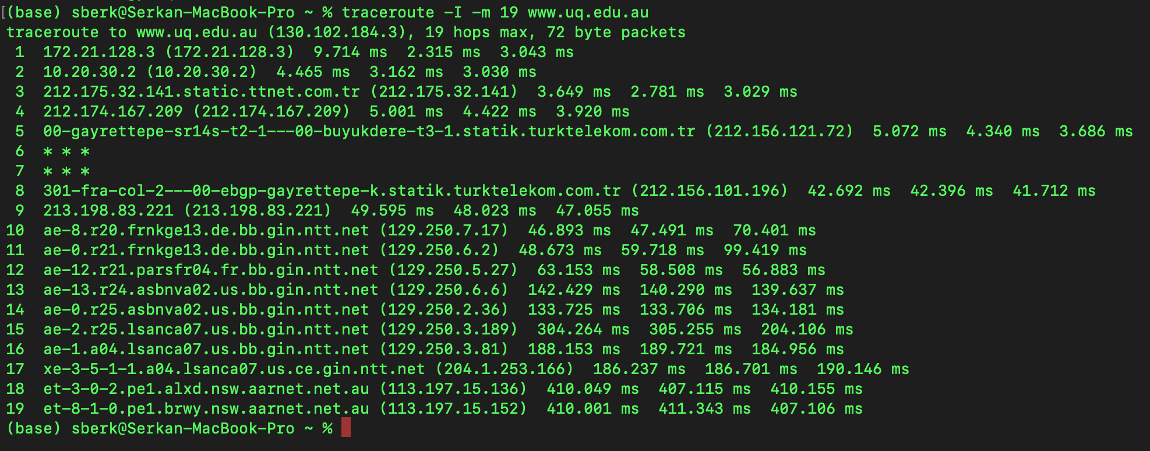

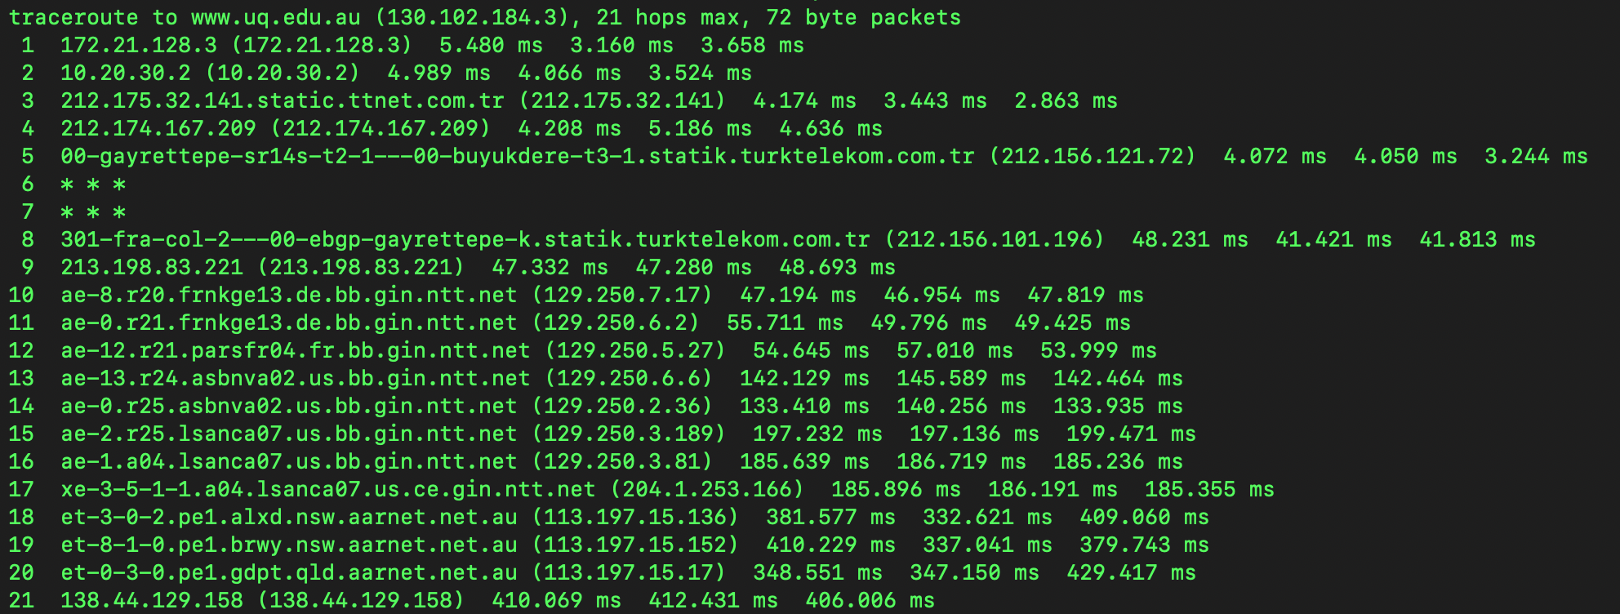

**Q2-** The default number of probes used on Macs are 3. It is 3 in my device. In the screenshots below you can see the outputs for different probes=1, 2, 4, 10. We can conclude that as number of probes increases the traceroute becomes more reliable since it will average the RTTs and if we sent only 1 packet(which mean probe=1) it will depend on immediate network conditions and other immediate things which will not be that reliable. Between different number of probes (1,2, 4, 10) the first few hops were generally was similar and consistent, less affected with the number of probes since they are initial routers, more close to us, local network in general. With multiple probes we observed more consistent results. In addition we need to keep in mind that sending more probes increases the load on the network, increases duration, and potentially affects the measurements’ accuracy. All these observations can be seen in the below screenshots.

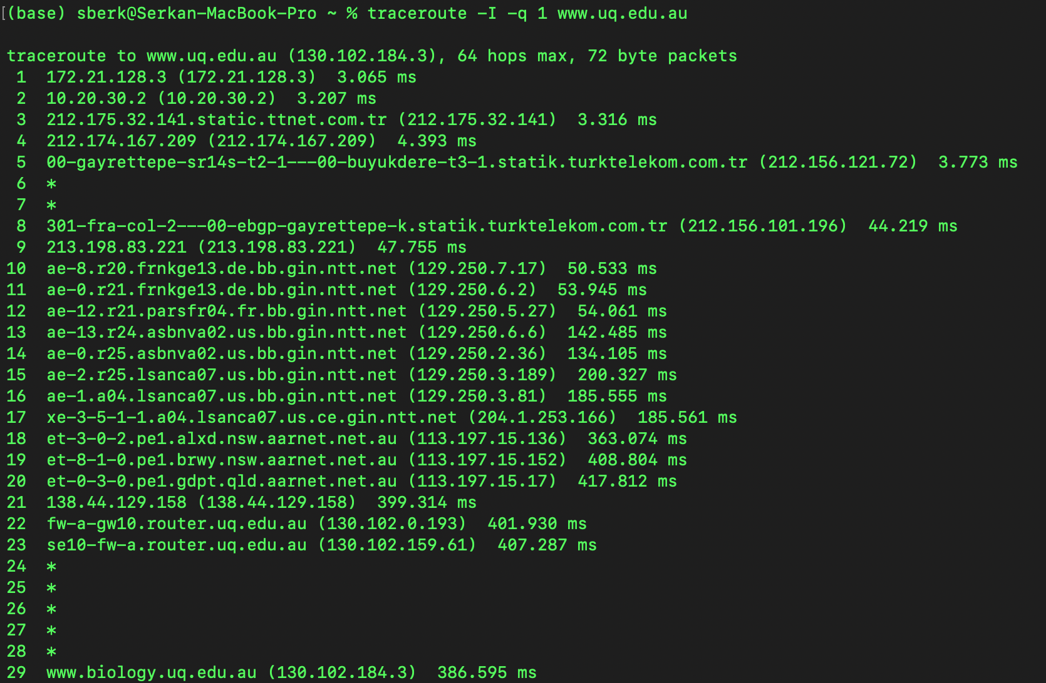

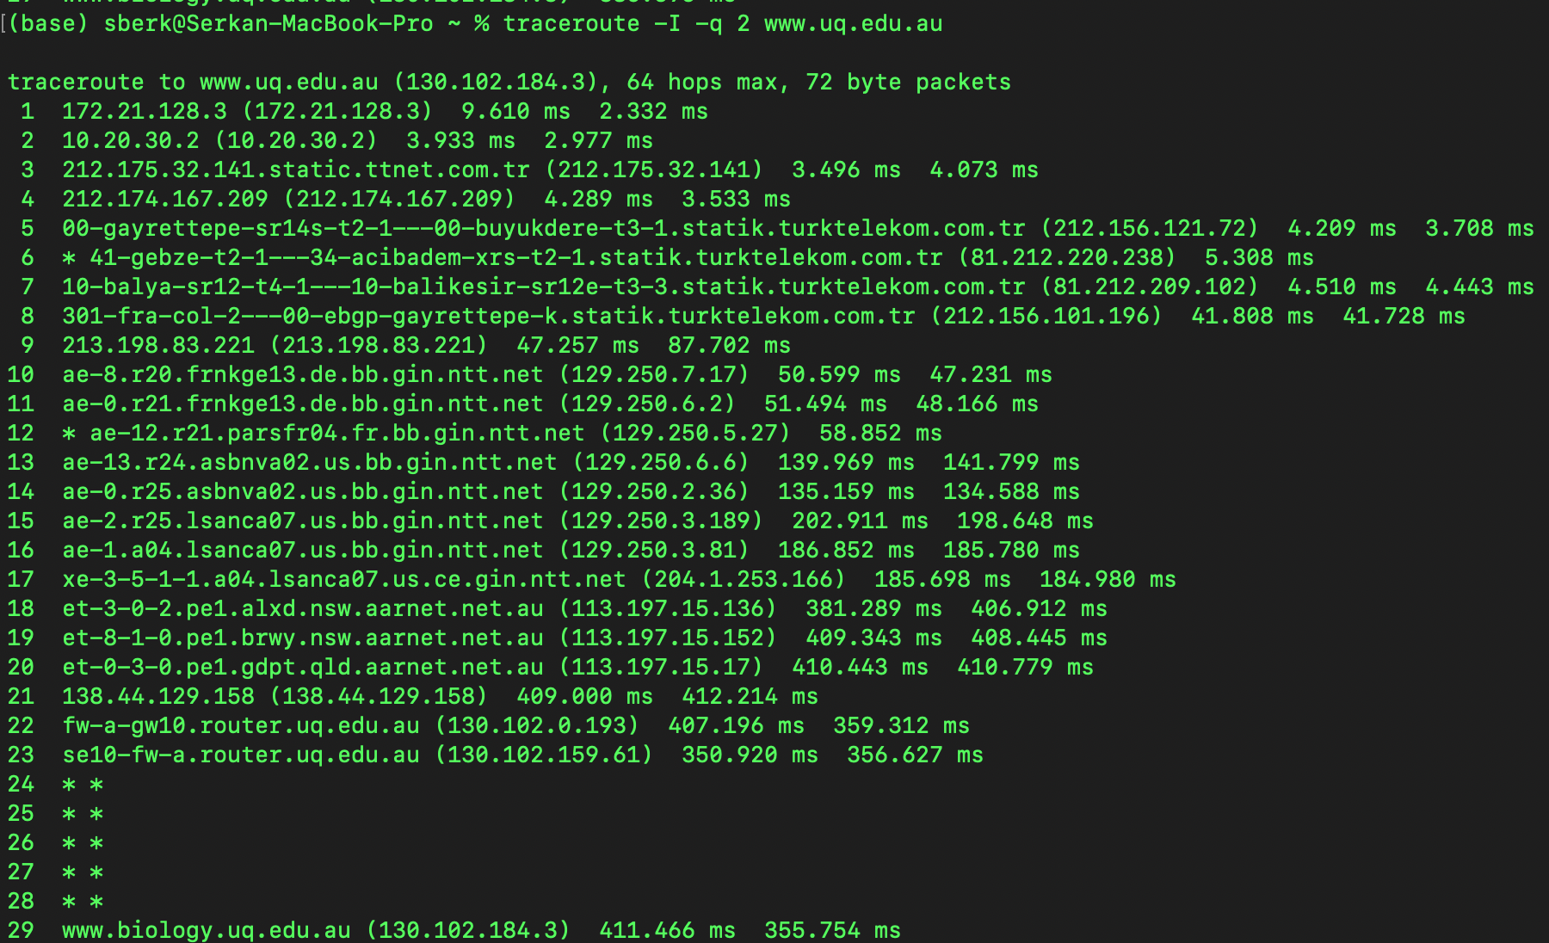

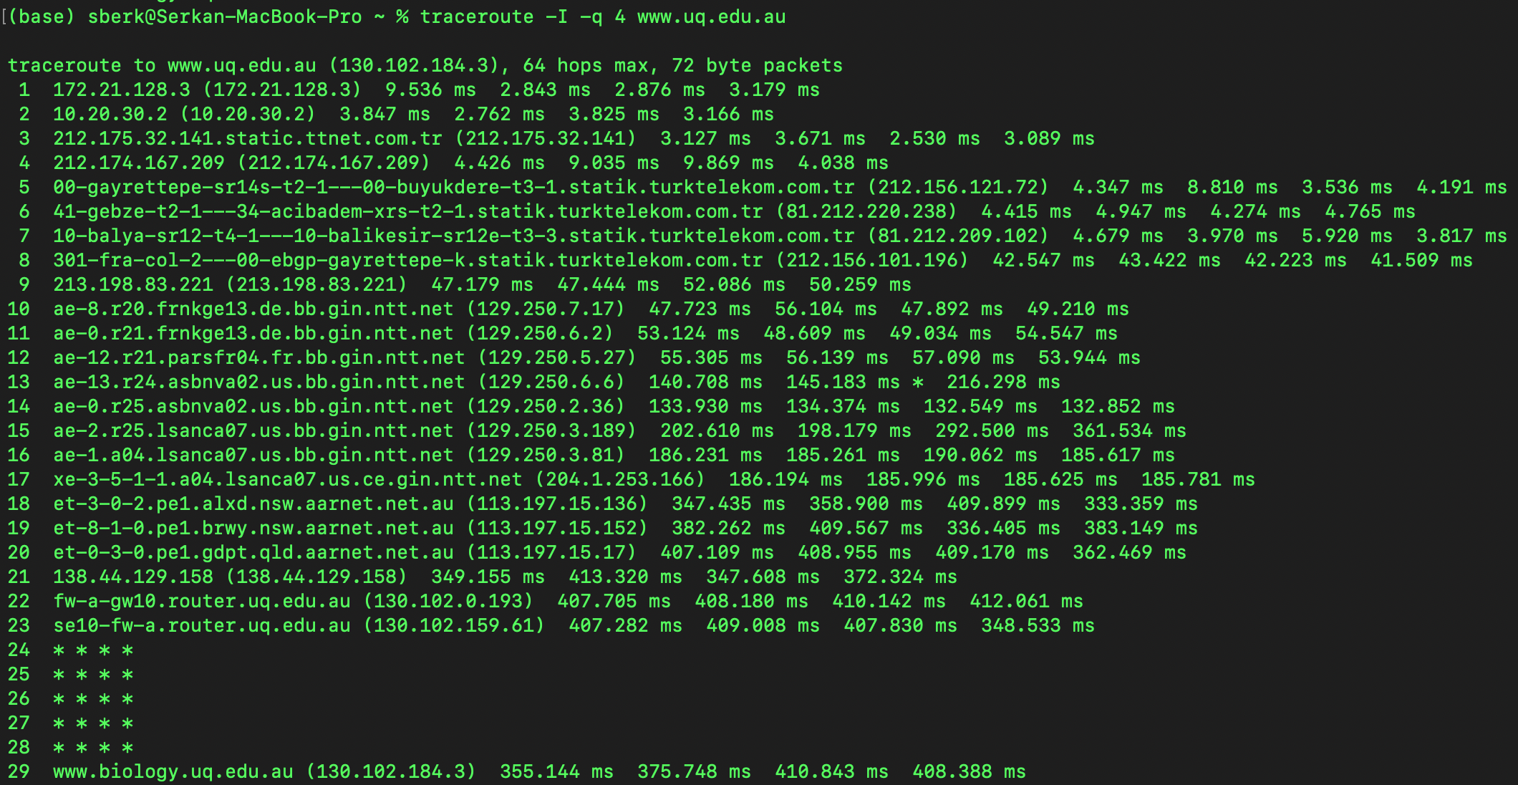

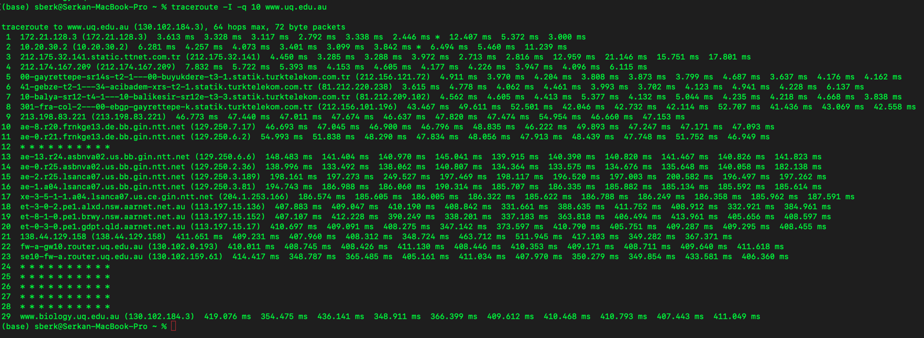

**Q3-** You can see the output of man traceroute below I used -I with traceroute to force the traceroute command to send ICMP packets instead of UDP.

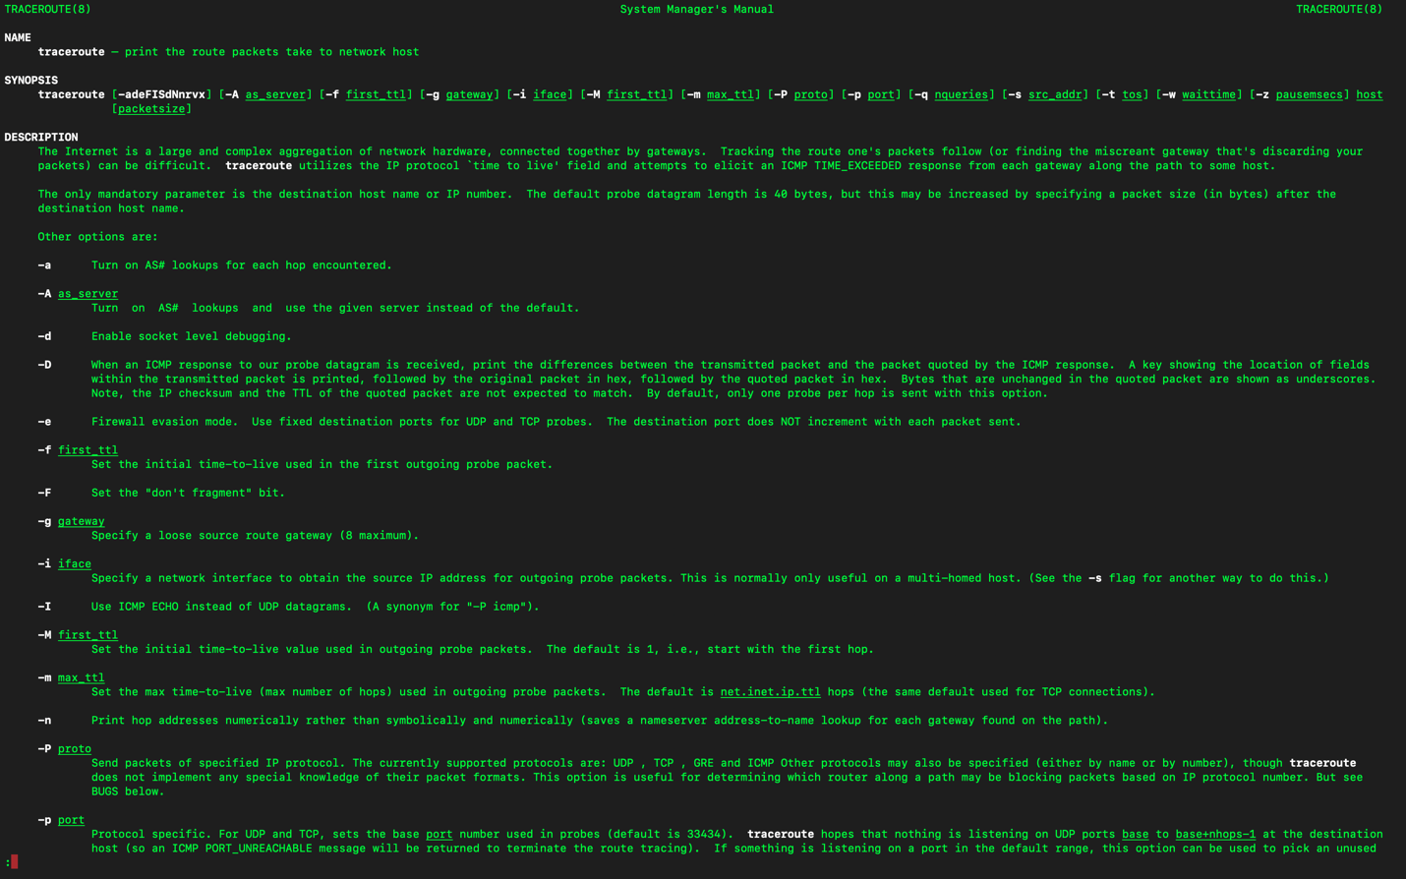

**Q4-** When traffic in a network is dropped or destroyed rather than sent to its intended destination, it's referred to as a **routing blackhole**. This might happen if there is a problem with the routing data, which prevents there from being a working path to the target network. A routing blackhole is essentially a spot in the network where packets go dead since there isn't a known way for them to get there.

Even though purposeful or managed blackholes in routing are generally undesirable and signal a network issue, there are several situations in which they might be advantageous. Using a method known as "blackhole routing" or "null routing" for particular objectives is one example of this.

An way of using Routing Blackholes beneficially is DDoS mitigation. We can configure a blackhole for targeted IP adress so that we are able to direct malicious traffic to a non-existent path, preventing it to reach the destination. This technique is commonly used. We need to keep in mind that it is a temporary solution to DDoS attack since it does not give any information about underlying cause of the attack.

**Part 1.2 Network Interface Analysis:**

**Q1-** I am using Mac and as can be seen from the below screenshots ip does not work but instead there is ifconfig. I will be using ifconfig and netstat for my commands.

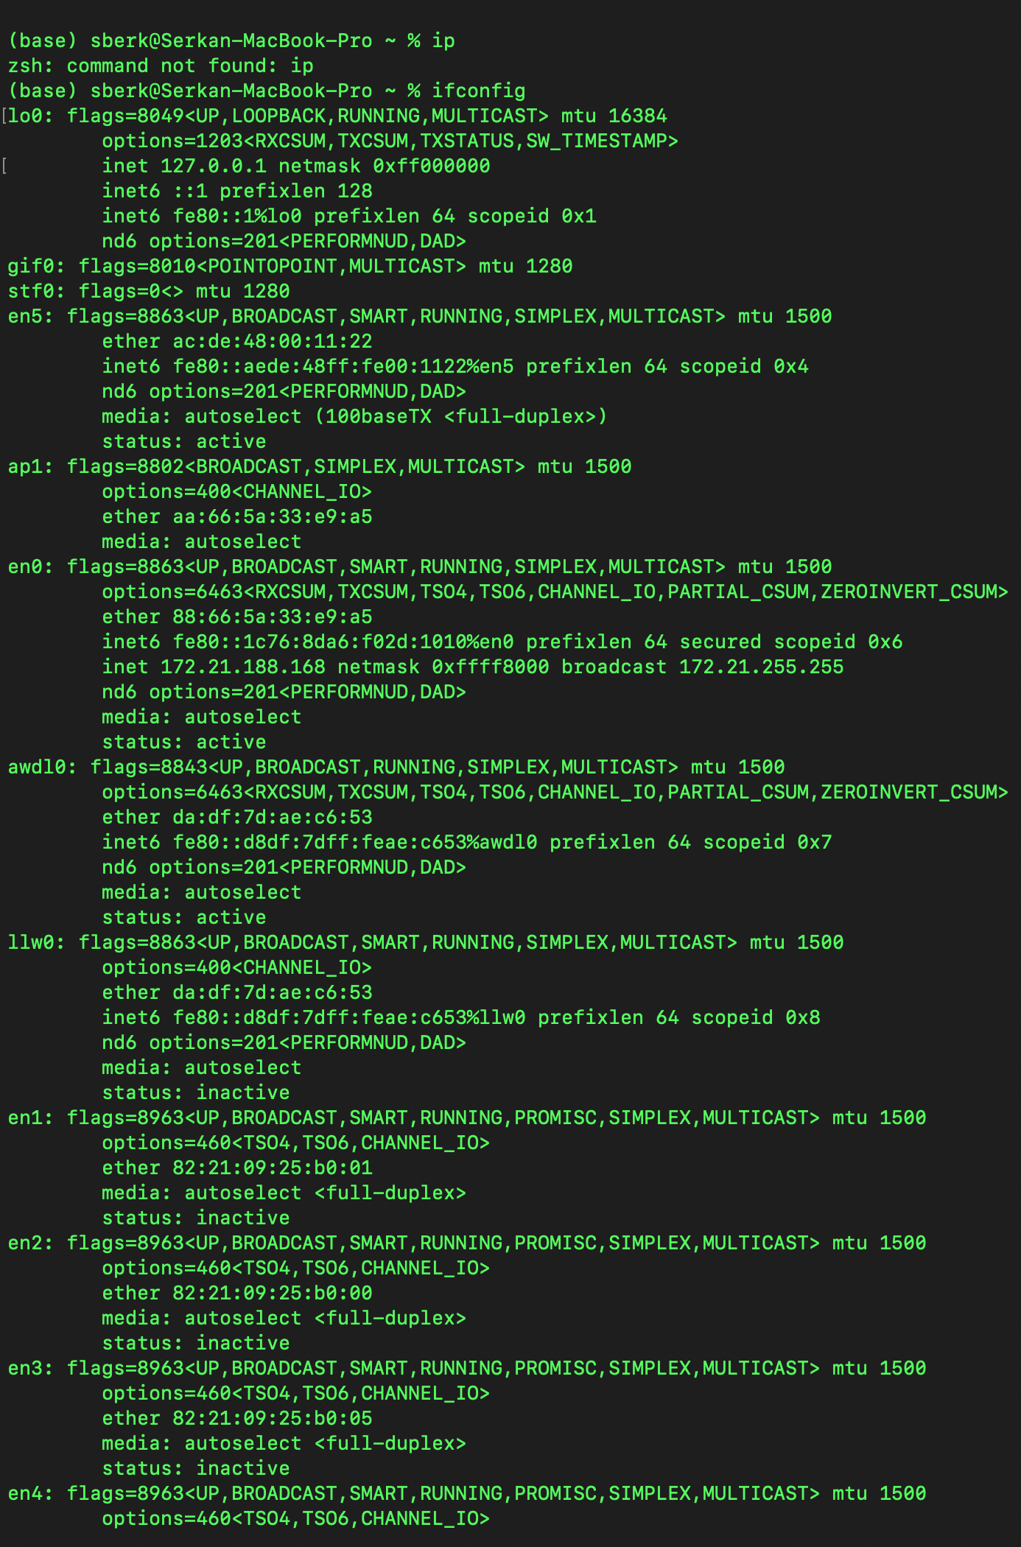

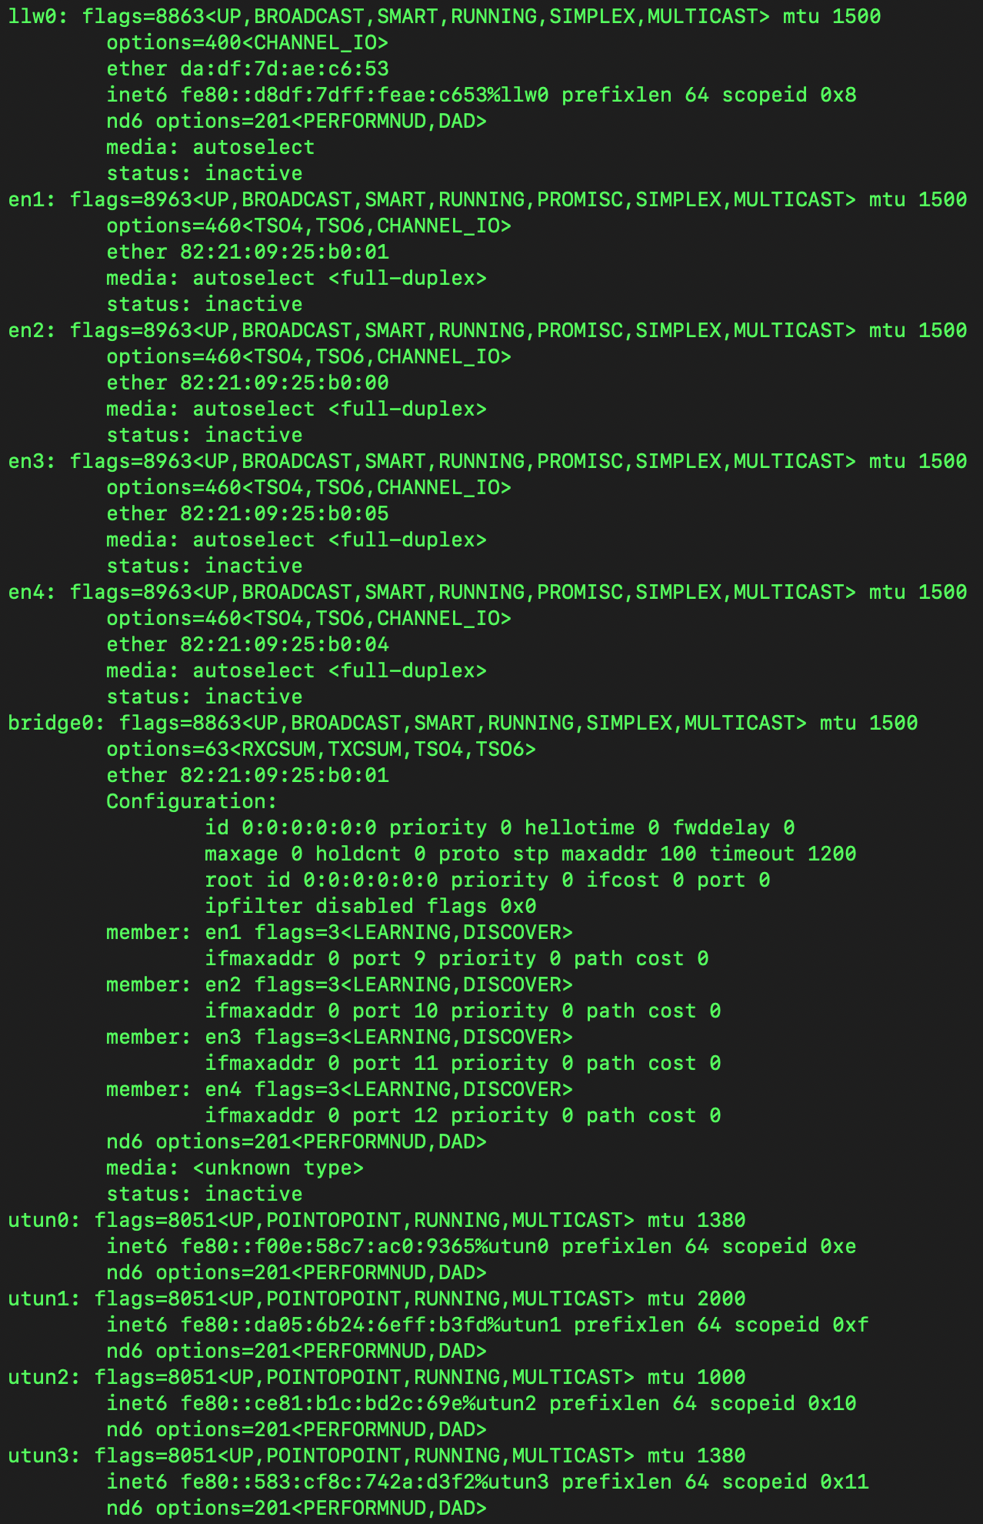

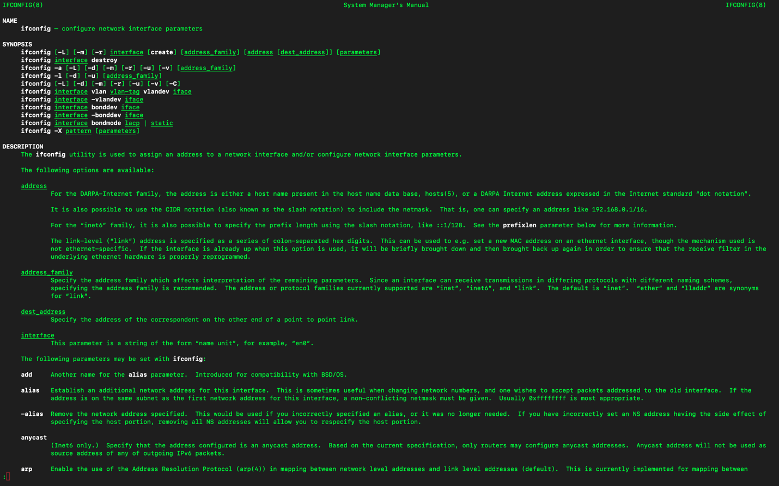

**Command 1: netstat -f inet -ix**

Netstat used to display various network-related information on macOS. Unfortunately ip did not work. It gave an erro that says *“command not found".*

In this command -f flag used to specify family name. There are other alternatives such as stated in **man netstat** inet for AF_INET, inet6, for AF_INET6, unix, for AF_UNIX and vsock, for AF_VSOCK. Inet for

**-f inet:** This option filters the output to display only IPv4-related information.

**-i:** Shows the state of interfaces which have been auto-configured (interfaces statically configured into a system, but not located at boot time are not shown)

**-x:** Shows the state of interfaces which have been auto-configured (interfaces statically configured into a system, but not located at boot time are not shown)

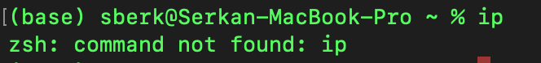

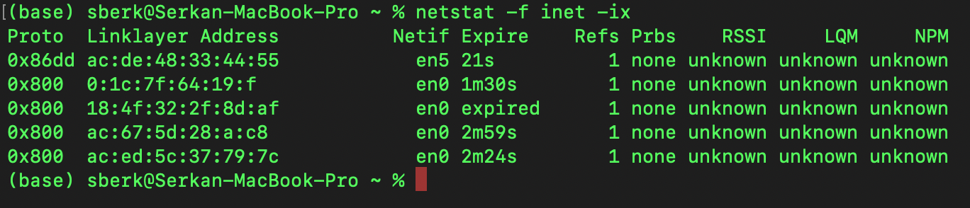

**Command 2: netstat -I en0 -w 1**

**-I en0:** This option specifies that you want to display statistics for a specific network interface, in this case, "en0." en0 is default primary built-in Wi-Fi network interface. I detected this running ifconfig. You can see the result of the ifconfig below as well.

**-w 1:** refreshes output every 1 second.

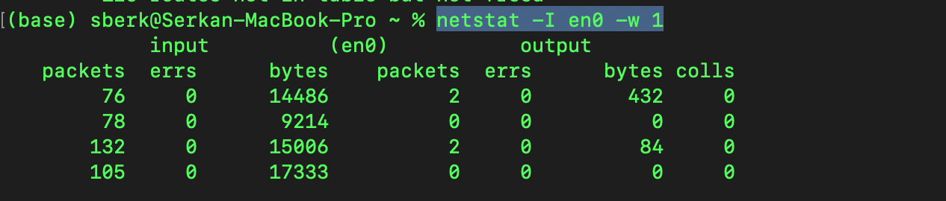

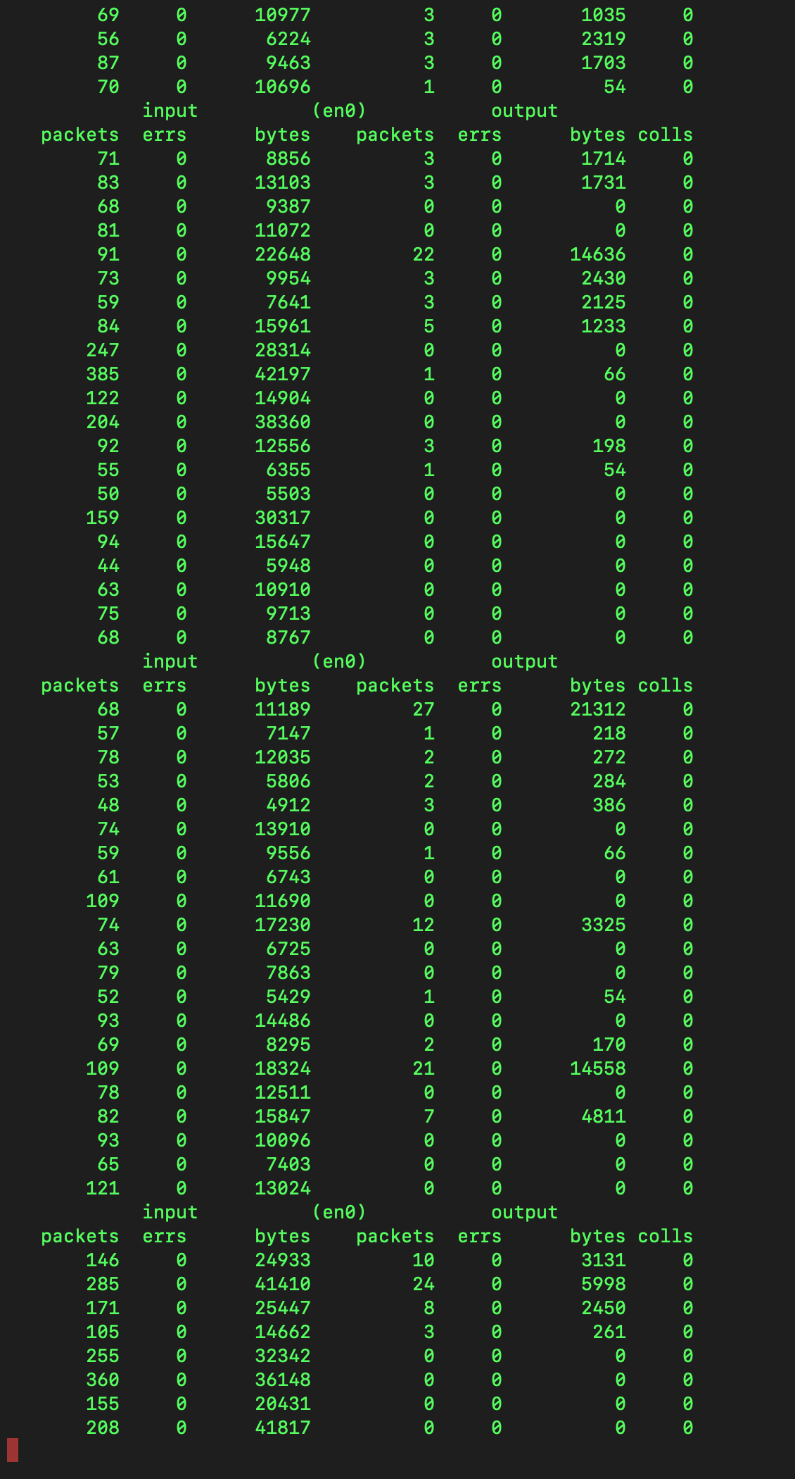

en0 can be shown below. After running ifconfig only active was this one. en1 not active as well. So this is default for Wi-Fi connection

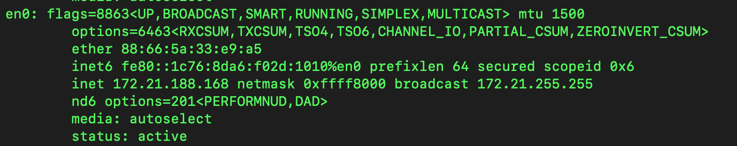

**Command 3: ifconfig -a -v -u -m**

**-a:** Displays information about all network interfaces, including those that are currently down.

**-v:** Provides more verbose output, including additional details about the network interfaces.

**-u:** Displays information only for interfaces that are currently up (active).

**-m:** Displays information about multicast groups.

You can see the screenshot of the output below.

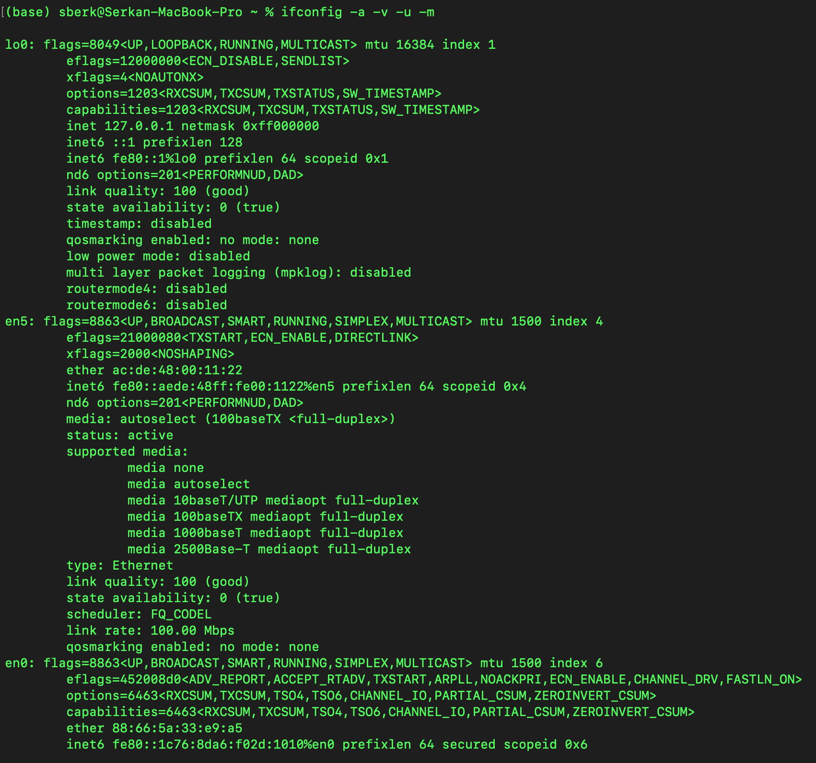

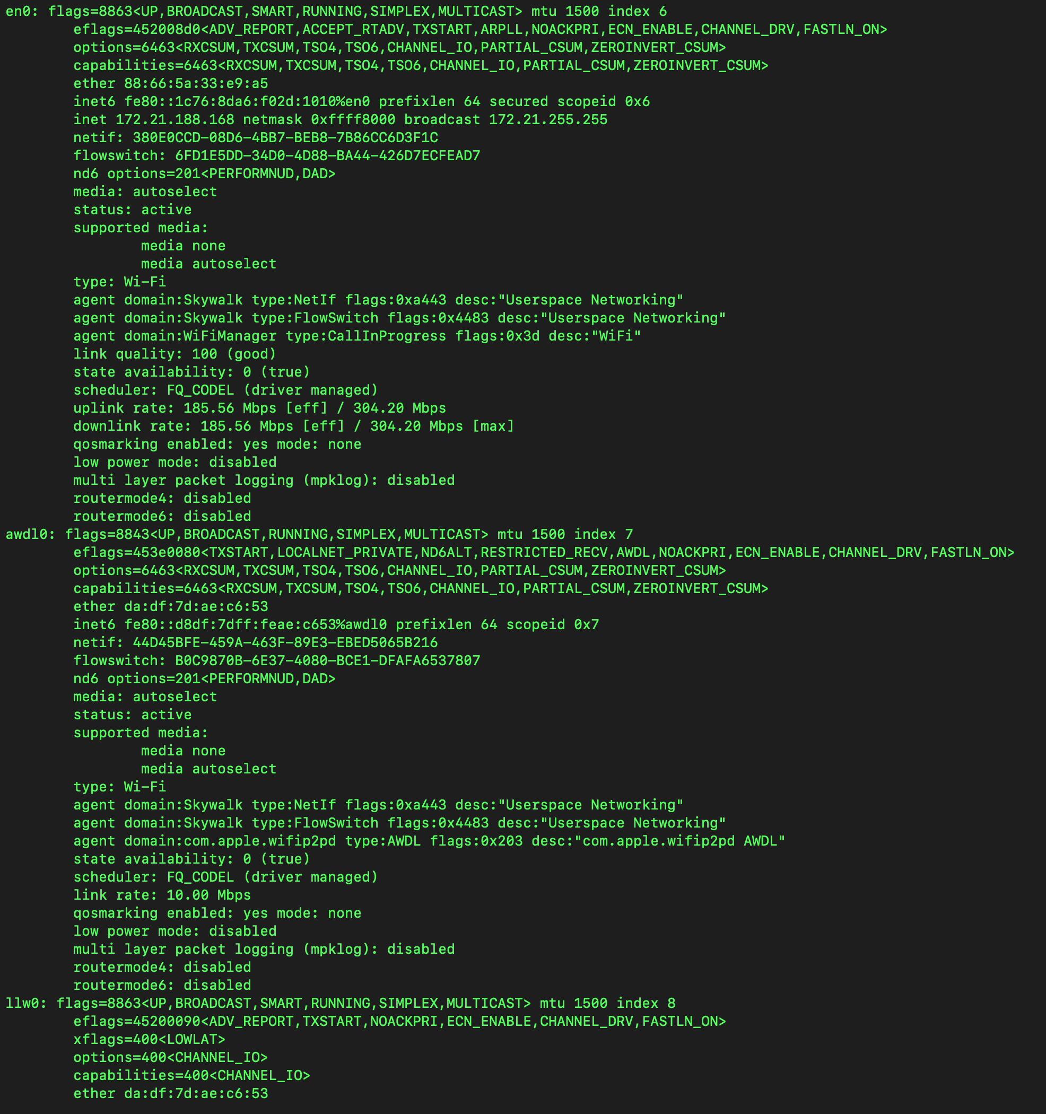

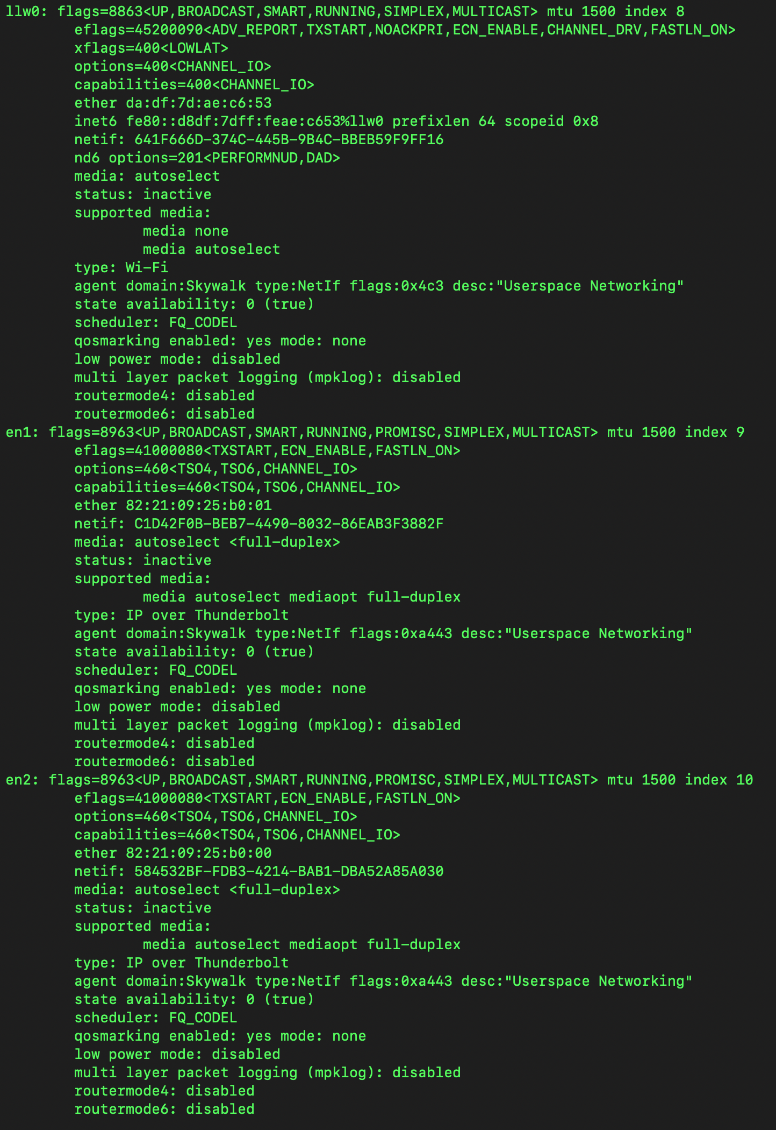

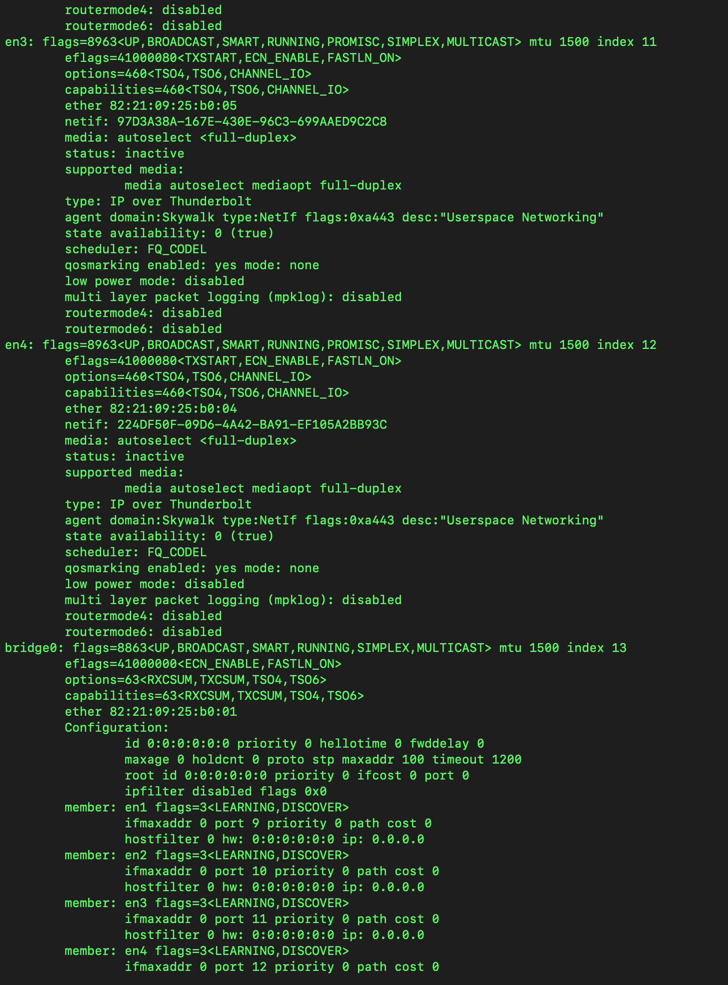

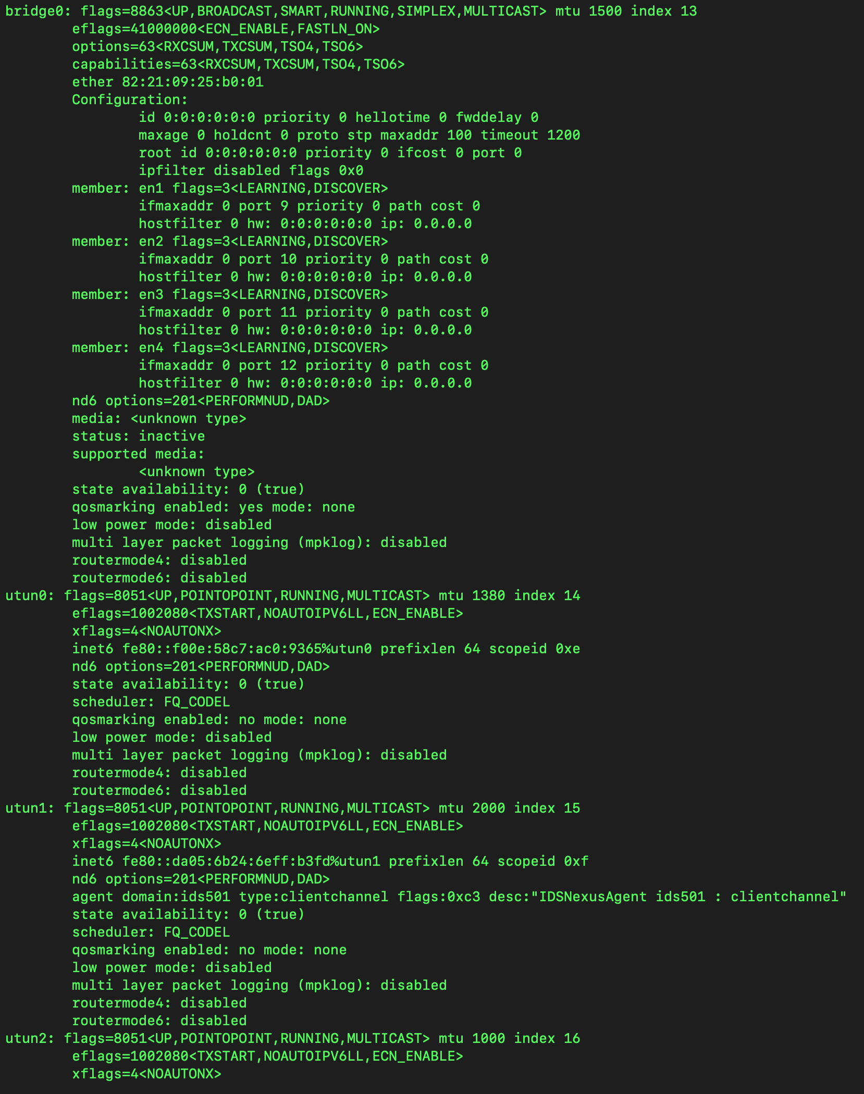

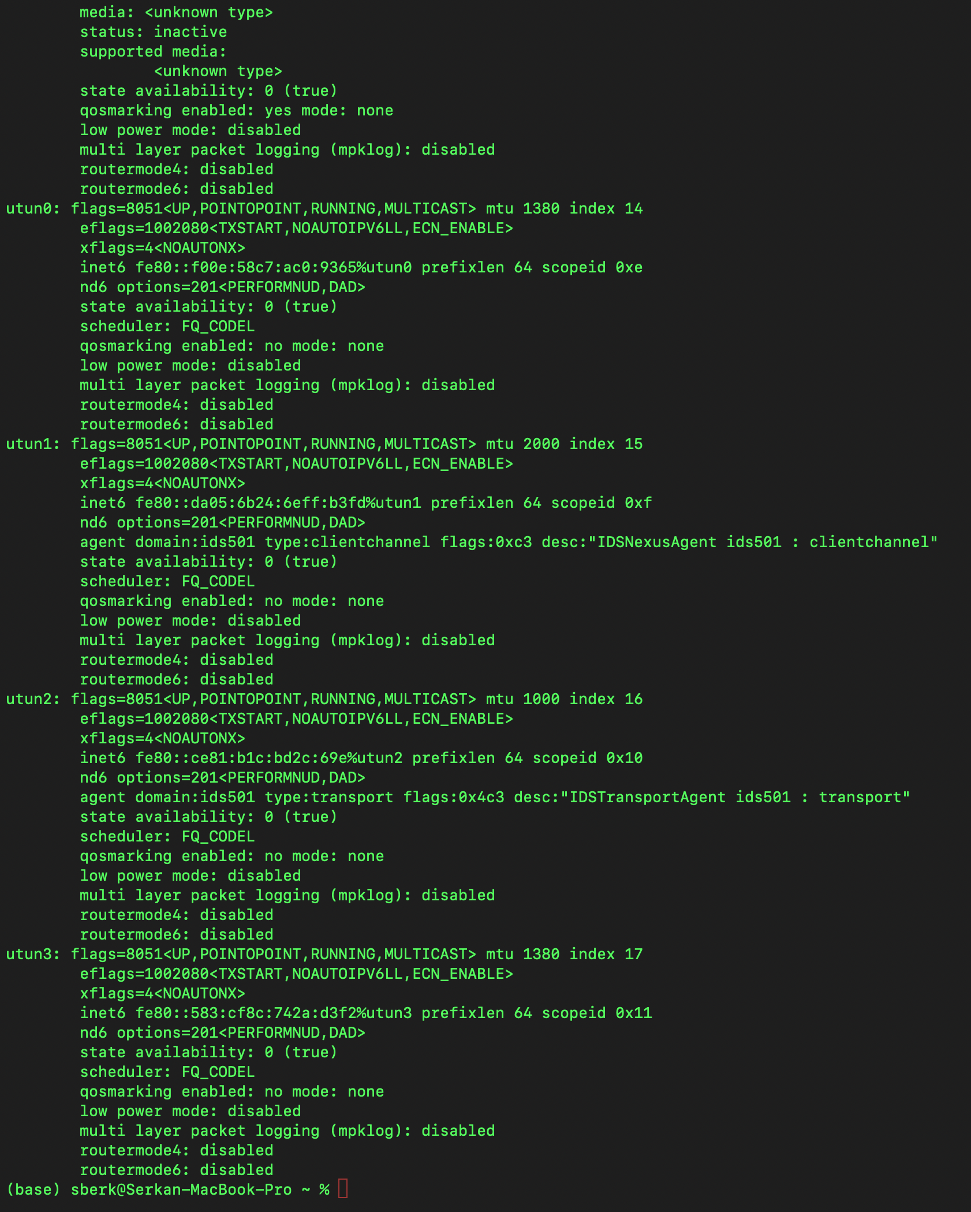

**Part 2. Understanding IP and Subnetting:**

**Q1-** I am using Wi-Fi connection and on Macs en0 is default primary network interface. It can be seen from the below 2 screen shots my IP address is 172.21.188.168 and default gateway is (in the 3rd screenshots) 172.21.128.1.

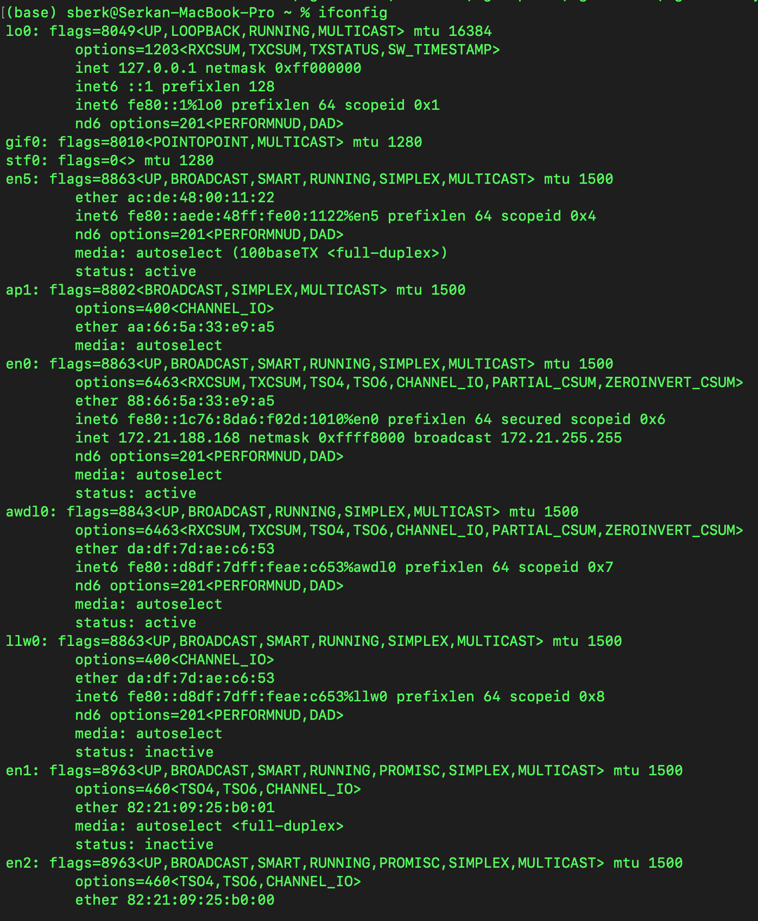

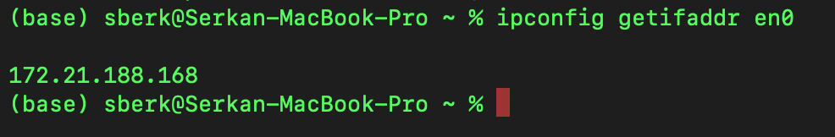

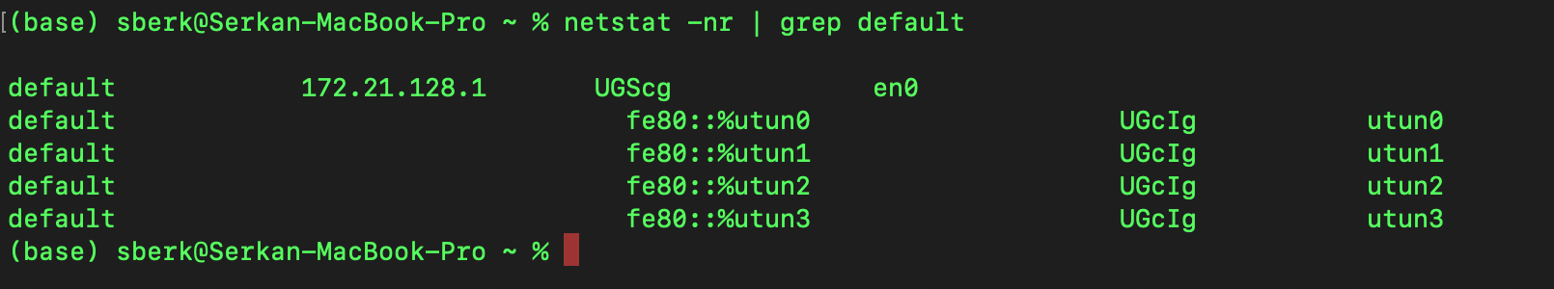

**Q2-** A subnet mask is a 32-bit(in IPv4) number that divides IP address into network and host. It helps breaking down a larger network into smaller, more manageable segments. It is expressed using CIDR (Classless Inter-Domain Routing) notation. For example “/22” indicates that the first 22 bits are part of the network, and the remaining 32-12=10 bits are used for host addressing.

**Q3-** Subnet mask is 0xffff8000 as can be seen from the screenshot.

Bitmask corresponding to it is: 11111111.11111111.10000000.00000000

There are 17 leading 1’s in the bitmask which means first 17 bits are part of the network and the remaining 32-17=15 bits are used for host addressing.

Subnet mask => 255.255.128.0

Subnet: 172.21.128.0/17

The network address is: 172.21.128.0

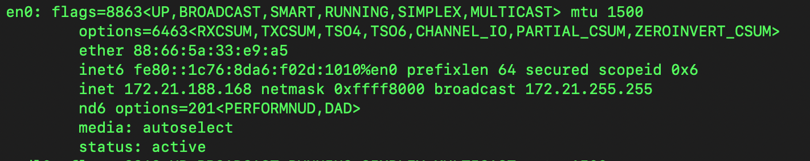

**Q4-** As can be seen in the screenshot **broadcast address is 172.21.255.255**. However we can also calculate from IP range which is 172.21.128.0 to 172.21.255.255. The first IP is reserved for network address and the last for broadcasting which is 172.21.255.255



**Q5-** Since 17 bits used for network part and remaining 15 for host part we can have up to 2^15-2 hosts connected to this subnet. -2 comes from 2 reservations first one is 172.21.128.0 for network address and the last one 172.21.255.255 for broadcasting.

**Part 3. Network Layer Analysis:**

**Q1-**

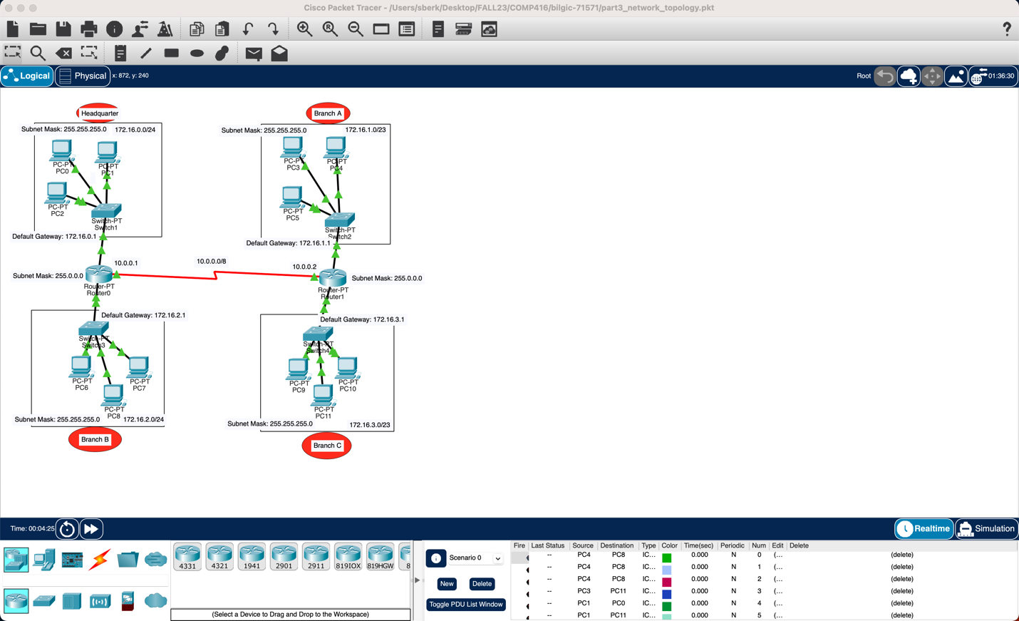

**Q2-**

I used Option III 172.16.0.0/20. Although I first selected Option I than I realized that option 1 has limited address space. I had to decide either I will allow 62 hosts inside branch and only 4 branches will not able to extend it if needed or will support up to 8 branches but will have at most 30 hosts inside each hosts. Option II is hard to remember, public and in our demo we give those kind of 10. 11. to routers, it is less human-readable. So I decided not to choose that one as well although it provides more flexibility and future scalability compared to other 2 options. It might be a good option for huge enterprises where there will be lots and lots of branches and lots of hosts inside branches. I thought Option III will be enough for medium-size enterprises in the below I explained usable ranges, network, broadcast addresses.In the question 4s answer I explained how many branches and hosts it support at maximum.

Headquarter: 172.16.0.0/24

* Subnet: 172.16.0.0/24
* Subnet Mask: 255.255.255.0
* Usable IP range: 172.16.0.1 to 172.16.0.254
* Network address: 172.16.0.0
* Broadcast address: 172.16.0.255

Branch A: 172.16.1.0/24

* Subnet: 172.16.1.0/24
* Subnet Mask: 255.255.255.0
* Usable IP range: 172.16.1.1 to 172.16.1.254
* Network address: 172.16.1.0
* Broadcast address: 172.16.1.255

Branch B: 172.16.2.0/24

* Subnet: 172.16.2.0/24
* Subnet Mask: 255.255.255.0
* Usable IP range: 172.16.2.1 to 172.16.2.254
* Network address: 172.16.2.0
* Broadcast address: 172.16.2.255

Branch C: 172.16.3.0/24

* Subnet: 172.16.3.0/24
* Subnet Mask: 255.255.255.0
* Usable IP range: 172.16.3.1 to 172.16.3.254
* Network address: 172.16.3.0
* Broadcast address: 172.16.3.255

**Q3-** In the below screenshot you can see all my calculations.

Bit representation.

10101100.00010000.00000000.00000000

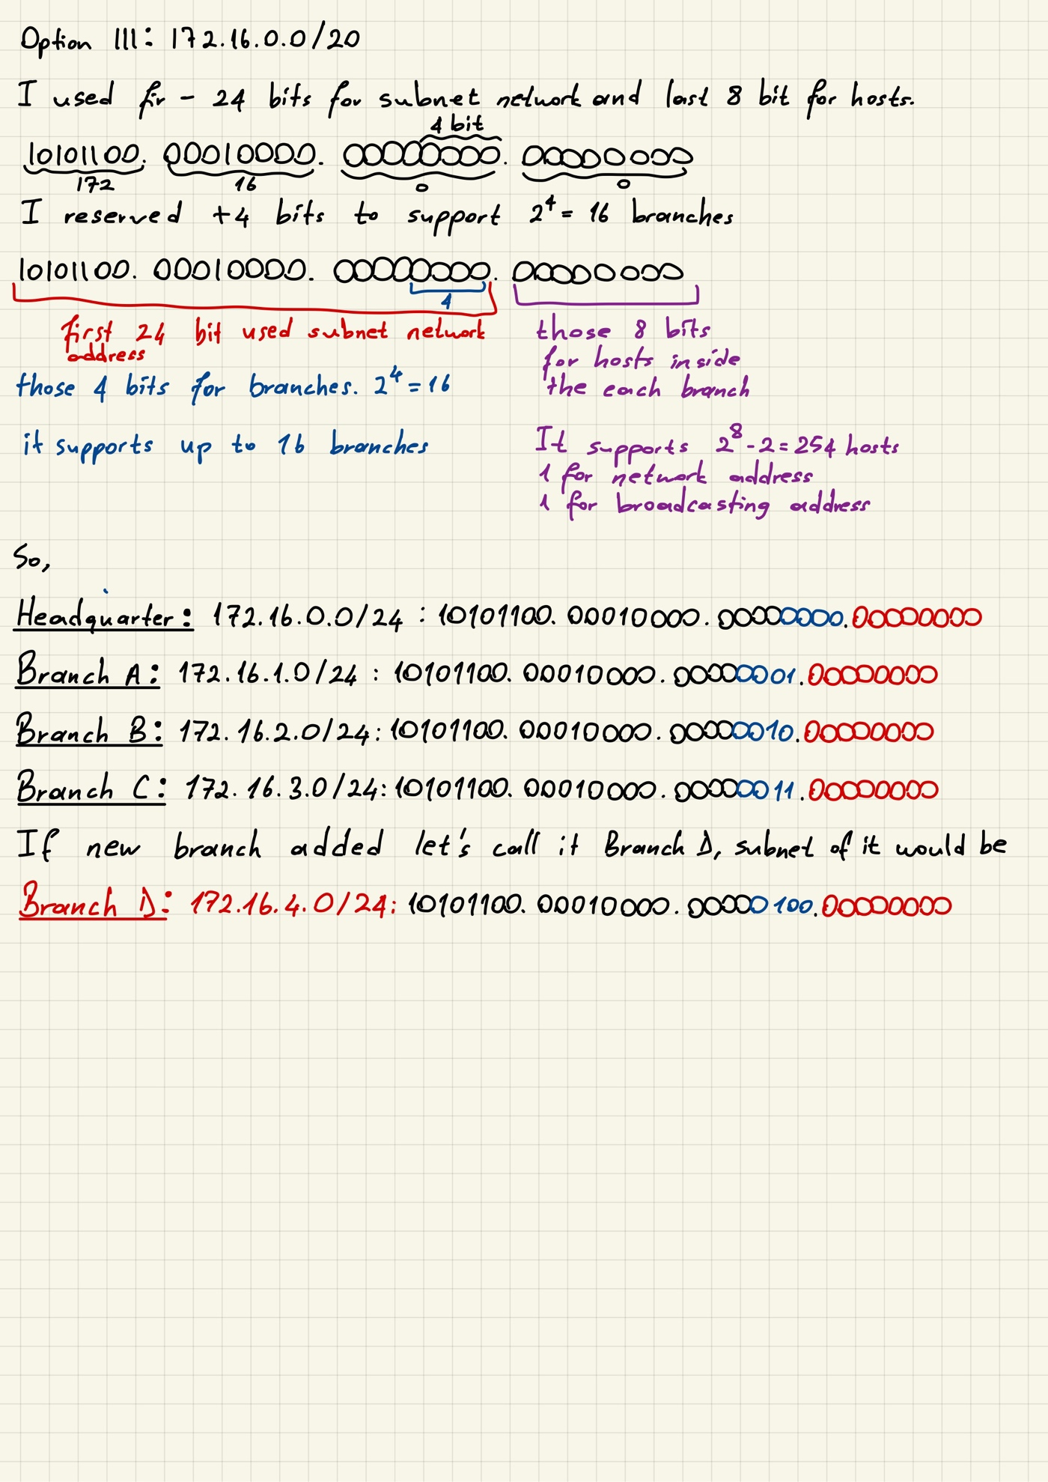

**Q4-**

|  |  |
| --- | --- |
| **Process** | **Command** |
| Entering to the privileged EXEC mode | *enable* |
| Global configure mode | *configure terminal* |
| Configuring interface between router and switch | *interface FastEthernet0/0* |
| Configuring interface between routers | *interface Serial2/0* |
| Assigning IP adresses to an interface – between routers | *ip address 10.0.0.1 255.0.0.0* |
| Assigning IP adresses to an interface – between router-switch | *ip address 172.16.2.1 255.255.254.0* |
| Configuring routing – route/switch | *ip route 172.16.1.0 255.255.255.0 10.0.0.2* |
| Configuring routing – route/route | *ip route 10.0.0.0 255.0.0.0 10.0.0.1* |
| Deleting existing routing | *no ip route 172.16.1.0 255.255.255.0 10.0.0.2* |
| Enabling routing | *No shutdown* |
| To exit | *exit* |

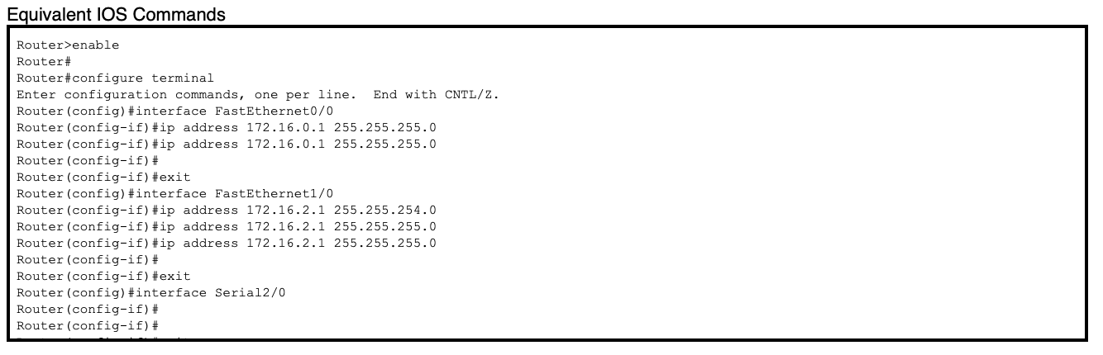

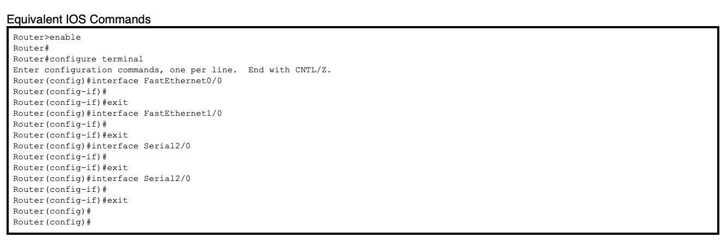

**Q5-** The command to show routing table using command line in Cisco is **show ip route.** Below you can see the screenshots of both the output after executing command and screenshot from GUI(static tab) of the router.

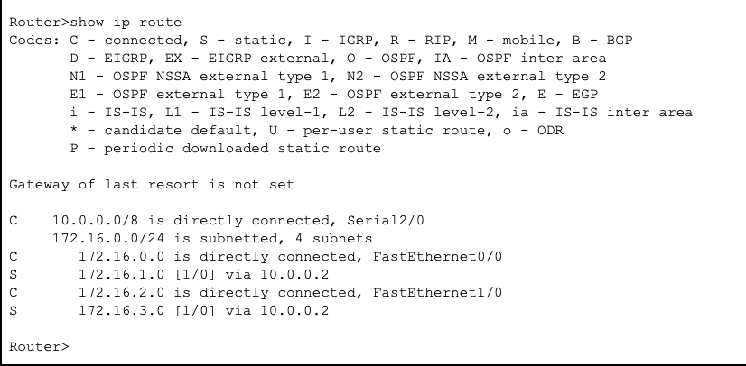

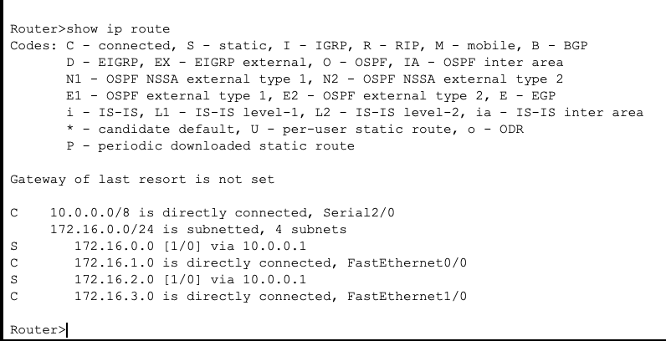

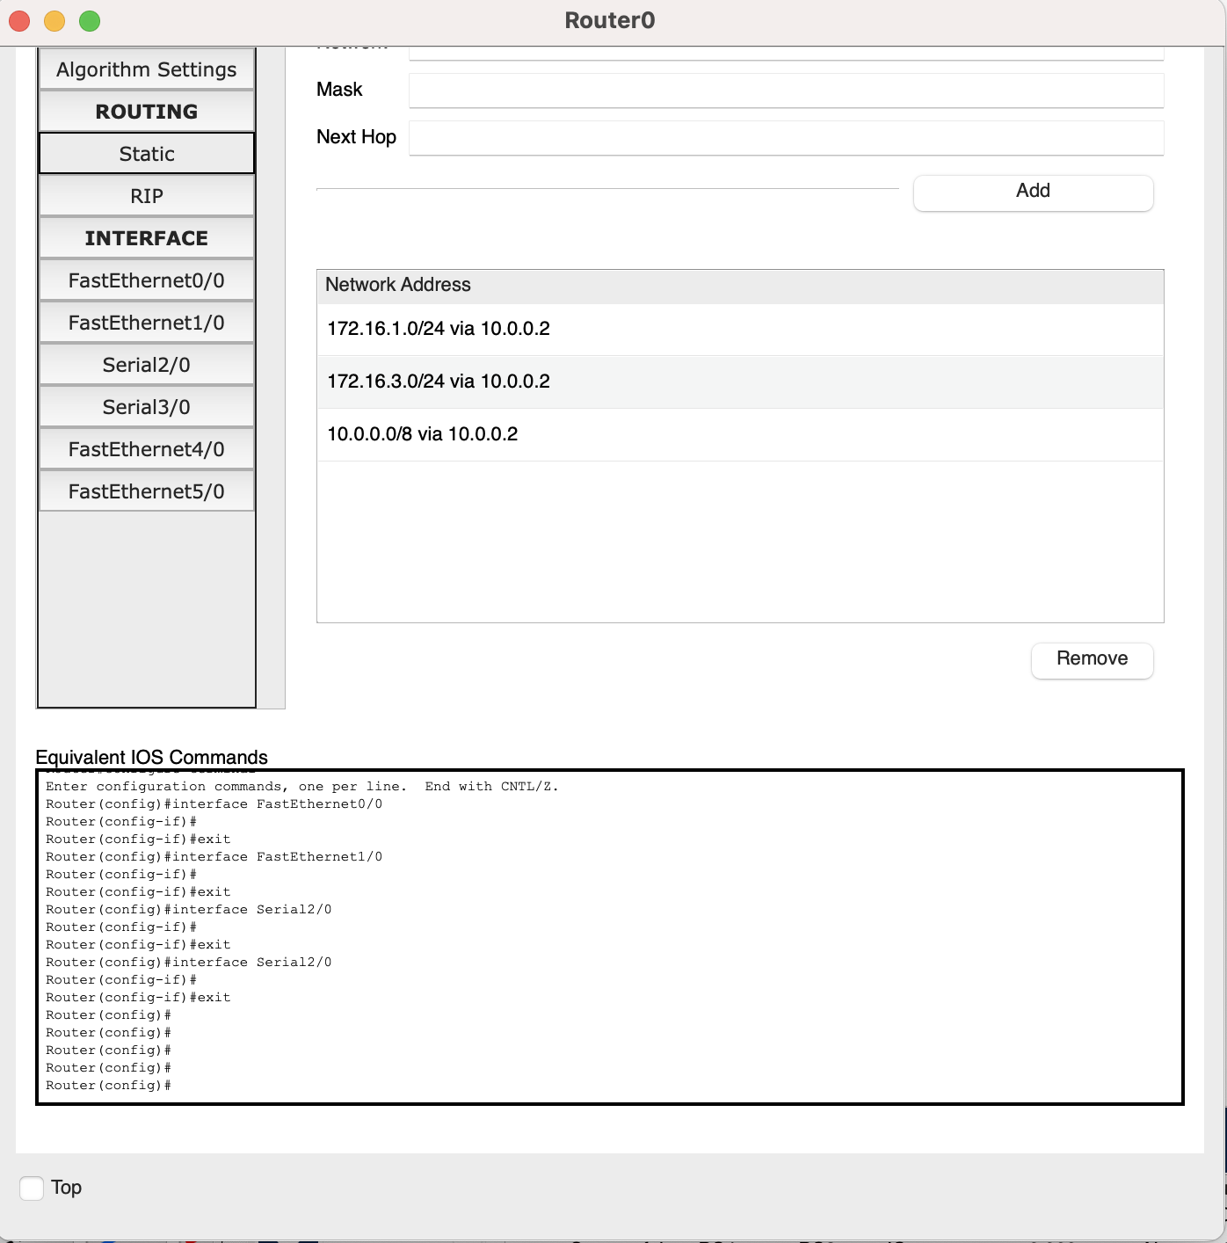

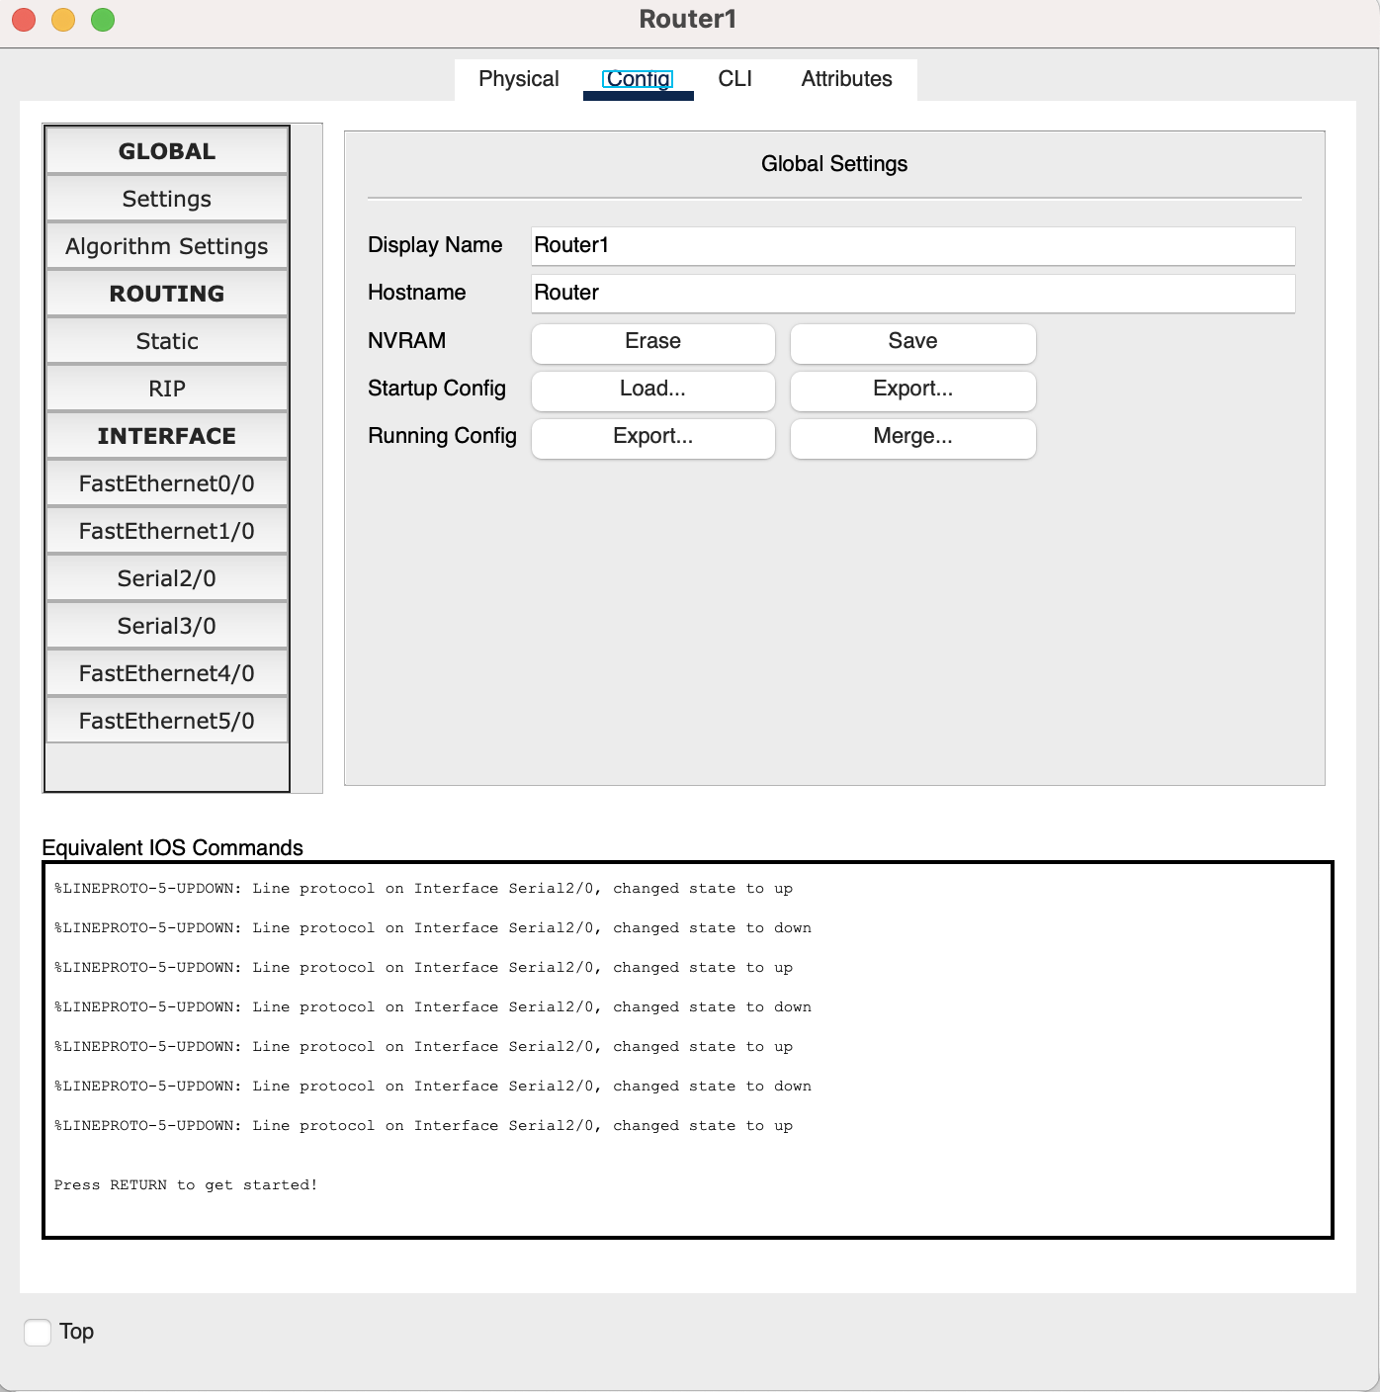

**Q6-** In the below screenshots you can see both sending envelope(ss.1) and pinging different hosts between same and different subnets from the CLI(ss.2 & ss.3). Screenshot 2 shows the PC3’s command prompt while the last screenshot taken from PC2’s. I tried with 2 different hosts in different subnets and I sent at least 4 ping request from each. First one to the host that is in the subnet with the host that I am sending ping. And other 3 to a different hosts each within the 3 different subnets to test all of them.

